**VAISHALI BOKADIYA**

**DAY 9 ASSESSMENT**

**UNIQUE VALUES AND JSON**

**Get unique values from list:**

There are various ways to get the unique values from list:

* **Using set():**

Code:

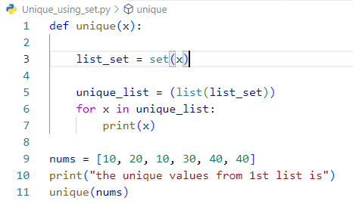

Output:

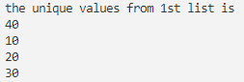

* **Using reduce()**

Code:

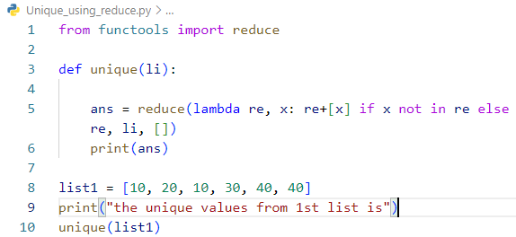

Output:



* **Using Operator.countOf()**

Code:

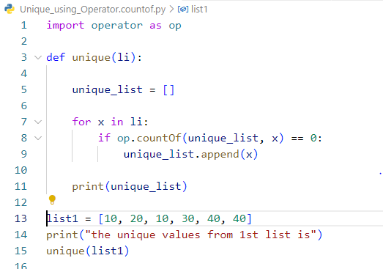

Output:



* **Using panda**

Code:

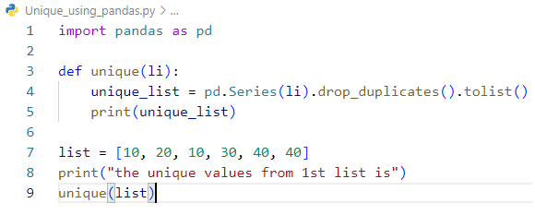

Output:



* **Using numpy**

Code:

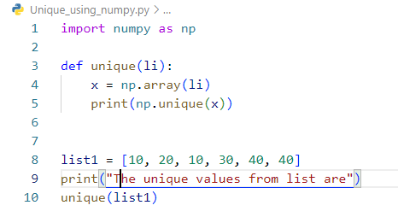

Output:



* **Using Collections.Counter()**

Code:

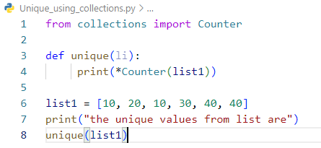

Output:



* **Using Dict.fromkeys()**

Code:

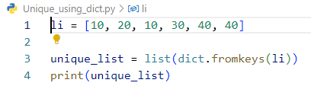

Output:



**Sort Python lists using key:**

Lists can be sorted in python using sorted() and sort().

Sorted() generates a copy of the list in a sorted way but doesn’t change the original list, whereas sort() changes the original list.

Code:

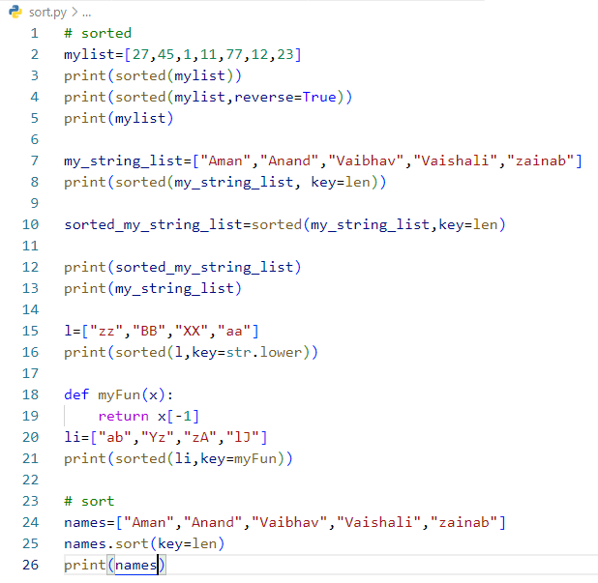

Output:

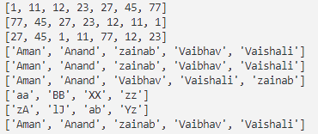

**Overview of JSON Strings and Files:**

JSON stands for JavaScript Object Notation. It is a format for structuring data.

**Features of JSON:**

* Easy to understand
* Can store any kind of data in an array of video, audio, and image.
* Support every language

**Read JSON data:**

**json.loads()** is used to parse the JSON string. It converts JSON string into Python Object.

Code:

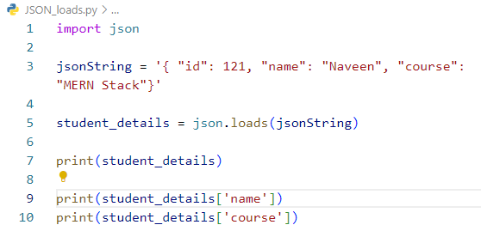

Output:

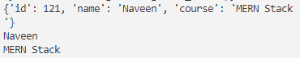

**json.dumps()** converts Python Object into JSON String.

Code:

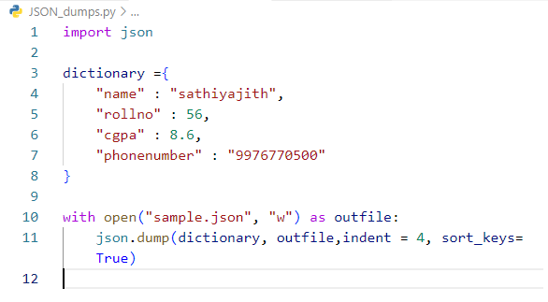

Output:

